HANNES GERHARDT
UNIVERSITY OF WEST GEORGIA
DEPARTMENT OF GEOSCIENCES
1601 MAPLE STREET, CARROLLTON, GA 30118
(678) 839-4064
hgerhard@westga.edu

ACADEMIC EMPLOYMENT

Fall 2007 – present University of West Georgia, Dept. of Natural Sciences
Professor

EDUCATION

2002 – 2007 University of Arizona - Tucson, AZ
PhD in Geography; split minor in Sociology and Anthropology
Advisor: Sallie Marston

Dissertation: The Geopolitics of Distant Suffering: U.S. Government and Faith based Responses to “Genocide” in Sudan

1996 – 2000 University of Oslo - Oslo, Norway
MA in human geography
Advisor: Kristian Stokke

1989 – 1994 University of Miami - Coral Gables, Fl.

BA in philosophy

RESEARCH & SCHOLARSHIP

Publications – Books

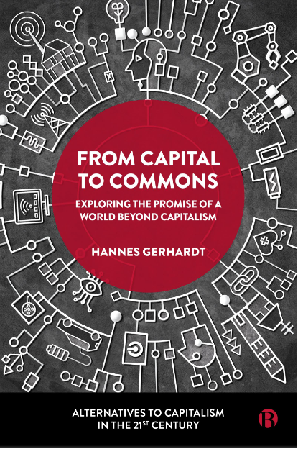 |  | Gerhardt, H. (2024) From Capital to Commons, Bristol University Press: Bristol, UK.
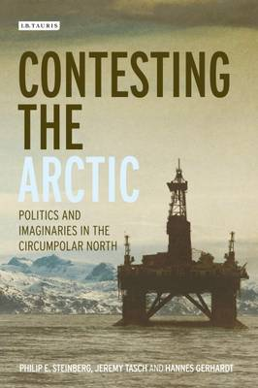 | Steinberg, P., Tasch, J., Gerhardt, H. (2015) Contesting the Arctic: Politics and Imaginaries in the Circumpolar North, I.B. Tauris/Macmillan: New York.

Publications – Articles

Gerhardt, H. (forthcoming) The Commons. In Akrivou, Kleio & González-Cantón, César (Eds). Elgar Business Ethics Encyclopaedia. Edward Elgar Publishing. Cheltenham, GLOS, United Kingdom.

Gerhardt, H. (2023) A commons approach to electricity. Transforming Society.
https://www.transformingsociety.co.uk/2023/09/13/a-commons-approach-to-electricity-provision/

Gerhardt, H. (2020) “Blockchains: Building blocks for a postcapitalist future? ” ROAR Magzine, November 6. https://roarmag.org/essays/blockchains-post-capitalism/

Gerhardt, H. (2020) “Engaging the non-flat world: Anarchism and the promise of a post-capitalist collaborative commons”. Antipode 52 (3), 681-701.

Gerhardt, H. (2020) “A commons-based peer to peer path to post-capitalism. An interview with Michel Bauwens. Antipode Online. https://antipodeonline.org/2020/02/19/interview-with-michel-bauwens/

Del Casino, V., House‐Peters, L., Crampton, J. W., Gerhardt, H. (2020) “The social life of robots: The politics of algorithms, governance, and sovereignty”. Antipode 52 (3), 605-618.

Gerhardt, H. (2017) “Book Reveiw: The Anarchist Roots of Geography: Toward Spatial Emancipation by Simon Springer”. Southeastern Geographer 57(3), 320-322.

Nicol, H., Webber, B., Barkan, J,. Steinberg, P, Tasch, J. & Gerhardt, H. (2016)
“Book Reveiw Forum: Contesting the Arctic: Politics and Imaginaries in the Circumpolar North”. The AAG Review of Books 4(3), 170-178.

Gerhardt, H. (2015) “Multiple Imperialisms: The Federal Reserve’s Response to the Global Financial Crisis”. Human Geography 8, 1-14.

Steinberg, P. E., Gerhardt, H. & Tasch, J. (2012) “The Arctic Model: Collaborative Governance in a Rapidly Changing Region”. Harvard International Review 34(1). Published online at http://hir.harvard.edu/crafting-the-city/thearctic-model.

Gerhardt, H. (2011) “The Inuit and sovereignty: The case of the Inuit Circumpolar Conference and Greenland”. Politik 1, 6-14

Gerhardt, H (2011) “Giorgio Agamben’s lessons and limitations in confronting the problem of genocide”. Global Ethics 7(1), 5-17.

Gerhardt, H. & Walter, A. (2010) “Teaching Financial and Monetary Hegemony in Geography”. Human Geography 3(3).85-88.

Gerhardt, H., Steinberg, P.,Tasch J., Fabiano, S, & Shields, R. (2010) “Climate Change and Contested Sovereignty in the Arctic”. The Annals of the Association of American Geographers 100(4), 992-1002.

Gerhardt, H. (2009) “Bio-Normative Geopolitics: The U.S. and the Darfur Crisis in Sudan”. Geopolitics 14(3), 488-509.

Gerhardt, H. (2008) “Geopolitics, Ethics, and the Evangelicals’ Commitment to Sudan”. Environment and Planning D: Society and Space, 26(5), 911-928.

Gerhardt, H. (2008) ”The role of ethical conviction and geography in religiously informed geopolitics: a response to Sturm”. Environment and Planning D: Society and Space, 26(5), 935 – 938
Gerhardt, H. and Stokke, K. (2001). “Industrial district or subordinated production? A case study of small-scale carpentry industries in Accra, Ghana”. Geografiska Annaler, 83B(4),
175-187

Publications - Book Chapters

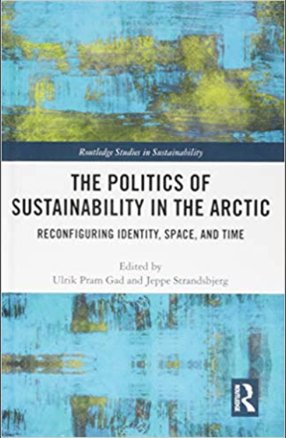 | Gerhardt, H., Stuvoy, K., Kristoferson, B. (2018) Green peace or oil riot. Affect, scale, and sustainability in the Arctic. In Gad, U. P. (Ed.) Postcoloniality and Sustainability in the Arctic. Routledge Studies in Sustainability, New York.

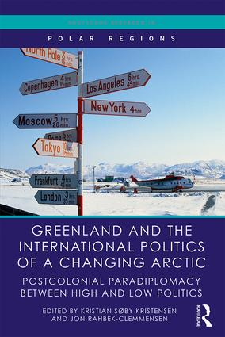 | Gerhardt, H. (2018) “The divergent scalar strategies of the Greenlandic government and the Inuit Circumpolar Council” in J. Rahbek-Clemmensen & K.S. Christensen (eds.) Greenland and the International Politics of a Changing Arctic – Postcolonial Paradiplomacy between High and Low Politics. Routledge, New York.
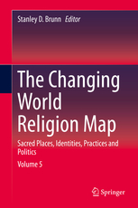 | Garmany, J. and Gerhardt, H. (2015) Global networks and the emergent sites of contemporary evangelicalism in Brazil. In Brunn, S. D. (Ed.) The Changing World Religion Map. Sacred Places, Identities, Practices and Politics. Springer, Netherlands, pp. 2011-2024.
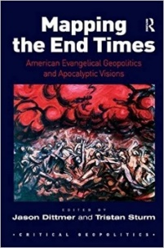 |  | Gerhardt, H. (2010) “The Problematic Synergy Between Evangelicals and the U.S. State in Sub-Saharan Africa” in J. Dittmer & T. Sturm (eds.) Mapping the End Times: American Evangelical Geopolitics and Apocalyptic Visions, Aldershot: Ashgate.
Papers Presented

2024 Annual Meeting of the Association of American Geographers, Hawaii (online),
The problem of scale in visions of a commons-based transition out of capitalism

2023 Annual Meeting of the Association of American Geographers, Denver,
Pursuing abundance through infrastructural commons

2018 Annual Meeting of the Association of American Geographers, New Orleans Greenpeace’s resistance and the challenge of geography

2017 Annual Meeting of the Association of American Geographers, Boston
“Future technologies and the end of state capitalism as we know it ”

2016 Annual Meeting of the Association of American Geographers, San Francisco
“ Future technologies' role in shaping future social movements”

2015 Southeastern Division of the Association of American Geographers Annual Meeting, Pensecoal, “ The Geographical Imperialisms of the U.S. Global Financial Crisis”

2014 Annual Meeting of the Association of American Geographers, Seattle
“Financial Crisis and the Fed's Post-territorial Imaginary”

2013 Southeastern Division of the Association of American Geographers Annual Meeting, Roanoke, “The Human Geography of the Appalachian Trail”

2013 The Sixteenth Biannual Appalachina Geography Conference, Pipestem State Park Resort, West Virginia “Human Geography and the Appalachian Trail”

2011 The Seventh International Congress of Arctic Social Science,
Akureyri Iceland “Greenland: Does an Inuit State Spell the End for a Circumpolar Inuit Identity.”

2011 Annual Meeting of the Association of American Geographers, Seattle
“Greenland: Potentials and Limitations of an Inuit State.”

2010 Annual Meeting of the Association of American Geographers,
Washington, DC “Competing Arctic Governmentalities and the Future of Greenland.”

2009 Southeastern Division of the Association of American Geographers Annual Meeting, Knoxville “The U.S. State and Evangelicals in Sub-Saharan Africa.”

2009 16th Annual Critical Geography Mini-Conference, Athens, GA
“Teaching Financial and Monetary Hegemony in Geography”.

2007 Annual Meeting of the Association of American Geographers, San Francisco
“Christian Advocacy for Sudan: Ethical-Geographic Imaginaries and Foreign Policy.”

2006 Annual Meeting of the Association of American Geographers, Chicago “Empire in the Popular Imagination – Culture and Hegemonic Space.”

2005 Annual Meeting of the Association of American Geographers, Denver
“The Genealogy of Genocide and its Geographical Implications.”

2004 Annual Meeting of the Association of American Geographers, Philadelphia
“The Fiction of the African State: Indistinct Spaces of Culture and Politics.”

1999 Nordic Africa Institute, Uppsala, Sweden “Does the Industrial District Model Apply to Africa?”

Invited Academic Lectures and Other Events

2024 Centre Internet et Société in Paris. “From capital to commons”. Online presentation and Q & A for the Commons Working Group colloquium.
2024 The Blockchain Socialist (podcast). Compeerism: How the Commons success where the Silicon Valley led digital revolution failed. https://theblockchainsocialist.com/compeerism-how-the-commons-can-succeed-where-the-silicon-valley-led-digital-revolution-failed/
2024 Georgia State University. “From capital to commons”. presentation and Q & A for the Department of Geosciences colloquium speaker series.

2023 Frontiers of Commoning, a Podcast Hosted by David Bollier (podcast). Hannes Gerhardt, From Capital to Commons. https://david-bollier.simplecast.com/episodes/hannes-gerhardt-compeerism-as-a-path-from-capital-to-commons

2021 The Blockchain Socialist (podcast). Avoiding co-optation of the commons under capitalism. https://theblockchainsocialist.com/avoiding-co-optation-of-the-commons-under-capitalism/

2021 The Postcpaitalism Podcast (podcast). Hannes Gerhardt on value, altcoins, and fixing the internet. https://postcapitalismpodcast.com/hannes-gerhardt/

2017 University of Greenland, Nuuk. “Interpreting Greenpeace oil rig occupations and responses in Russia, Norway, and Greenland.”

2015 Georgia State University: “The Geographical Imperialisms of Dollar Hegemony”, presentation and Q&A for the Department of Geography’s colloquium series.

2011 Georgia State University: “Qualitative Research: From Evangelicals to the Arctic”, presentation and Q&A for Dr. Hankins’ Graduate Seminar on Geographical Methods

2009 University of West Georgia: “The Problematic Synergy Between
Evangelicals and the U.S. State in Sub-Saharan Africa”, presented for Lambda Alpha, National Collegiate Honors Society for Anthropology.

2008 University of West Georgia “The Cultural Dimensions of Small Scale Carpentry Production in Accra, Ghana”, presented for Lambda Alpha, National Collegiate Honors Society for Anthropology.

Reseach Collaboratives

2017 Research team member: Politics of Postcoloniality and Sustainability in the Arctic Workshop, Nuuk, Greenland. Funded by Velux Foundation grant, $877,000.

2016 Research team member: Politics of Postcoloniality and Sustainability in the Arctic Workshop, Copenhagen. Funded by Velux Foundation grant, $877,000.

Grants and Awards

2020 UWG School of the Arts (SOTA)
Best Damn Lecture of the Year Award – SOTA: The Other Night School

2015 Fulbright Arctic Initiative Scholarship – (not funded)
Energy Futures of Greenland and Norway

2014 University of West Georgia SRAP Grant – (funded)
Calculating UWG’s Carbon Footprint, Part II – Total award: $2000.

- U.S. Department of Education (co-PI) – (funded)
Designing Technology-Enhanced, Inquiry-Based Lessons Using GIS.
(Awarded January 2013) – Total award: $55,556. Gerhardt component: $2,400.

2013 University of West Georgia SRAP Grant – (funded)
Calculating UWG’s Carbon Footprint – Total award: $2000

2012 UWG – College of Science and Math Excellence in Research Award
Total award - $1000

2009 – 2013 National Science Foundation (PI) – (funded)
Collaborative Research: Territorial Imaginaries and Arctic Sovereignty Claims. Funded by the National Science Foundation’s Geography & Regional Science and Arctic Social Sciences Programs. (Awarded August 2009). Total for three universities: $376,779; University of West Georgia Component: $82,710

2008 National Science Foundation (PI) – (not funded)
“Collaborative Research: Reterritorializing the Arctic: Virtuality and Materiality in Contested Sovereignty Claims”.

1998 Nordic Africa Institute, Uppsala, Sweden (PI) – (funded)
Spatial Forms of Cooperation and Production Among Small Scale Carpentry Shops in Accra, Ghana. Travel grant: $4000

TEACHING

GEOG 1013: World Geography

GEOG 2010: Political Geography

GEOG 2053: Cultural geography

GEOG 2202: Environmental Science

GEOG 3020: Political Geography

GEOG 3405: Geographies of Sustainability

GEOG 3085: Geography of the E.U.

GEOG 4500: Moral Geographies

GEOG 4082: Phenomenology of Place

GEOG 4082: The Geography of Global Financialization

GEOG 4083: Senior Capstone

GEOG 4253: The Geography of Money

Online Sustainability Module: An online learning module offered to all UWG faculty for use in their classes to build basic sustainability literacy – Created in 2016

Pedagogical Workshops and Trainings

2019 Co-Leader, Campus as a Learning Living Laboratory for Teaching Sustainability, UWG, Carrollton

2016 Co-leader, Sustainability Across the Curriculum Workshop for Faculty, UWG, Carrollton

2016 Participant, Academic Affairs, Faculty Symposium on LEAP, UWG, Newnan

- Participant, AASHE Sustainability across the Curriculum Leadership
Workshop, Emory, Atlanta

2012 Participant, UWG Online & the Faculty Development Center, Cohort for Online Instruction and Course Development (summer training), UWG, Carrollton

Faculty Led Student Research

2023 Rose Jabat: Impacts of native and non-native plants on soil.

2022 Brendan Jones: Littering in Paulding County

2022 Jonathan Stober: Surveying Environmental Awareness and Action in College Students

2021 William Hitchcock: Mapping Pollution from Georgia's Powerplants

2021 Heather Van Gilder: Sustainable Energy Use on the UWG Campus

2020 Gyselli Hernandez: Location of Marijuana Dispensaries in Denver, CO

2020 Madison Cobb: Recycling Pathways from UWG

2014 Lillie Cornelison: Calculating UWG’s Carbon Footprint

External Faculty Led Student Research Presentations

2014 College of Science and Mathematics Research Day. Lillie Cornelison, Calculating UWG’s Carbon Footprint

SERVICE

University – Committees and Other (beyond department)

2023 – Present CMCS Executive committee (College)

2022 – 2024 Program Coordinator for Geography (College)

2022 – 2023 CACSI Leadership Fellow Program

2021 – 2023 Co-chair, CACSI Faculty Advisory Committee (College)

2020 – 2021 Member, CACSI Faculty Advisory Committee (College)

2020 – 2021 Member, CACSI Executive Committee (College)

2020 – 2022 Member, Faculty Budget Committee (Senate)

2012 – 2020 Chair of the UWG Sustainability Council

2014 – 2020 Director of Sustainability for UWG

2017 – 2020 Member, Institutional Planning Committee (Senate)

2020 UWG Best of the West, Sustainability Champion of the Year

2019 Member, UWG Presidential Search Committee

2014 – 2017 Member, Faculty Senate

2014 – 2017 Member, Undergraduate Programs Committee (Senate)

2008 - 2014 Coordinator, Environmental Studies Program, University of West Georgia

2013 – 2014 Member, Strategic Planning 2020 Committee (President’s Office)

2011 – 2013 Member, Strategic Planning Committee (Senate)

2012 Co-founder of the UWG Sustainability Council

2012 Member, Search Committee for Associate Vice President for Research & Sponsored Projects

2011 – 2012 Member, Ad-hoc Policies, Procedure, and Planning Committee (COSM)

2008 – 2012 Faculty advisor for STAND, student anti-genocide coalition

2009 – 2011 Member, Academic Policies and Procedures Committee (Senate)

2010 –2011 Member, Grade Appeals Subcommittee of APPC (Senate)

2009 Task Force on Interdisciplinary Studies, College of Arts and Sciences

Community Outreach – Editorials, Talks, Interviews, Panels, Judging

2025 Judge: UWG’s Academic Research and Experiential Learning Week. Public debate on environmental issues, UWG debate team.

2024 Talk: Great Decisions Program (Foreign Policy Association), sponsored by the League of Women Voters, Carrollton, GA: “Global Trade and Green Energy”.

2024 Judge: UWG sponsored High School Ethics Bowl judge.

2023 Panel Member: UWG Ethics Week, Carrollton, GA, member of faculty ethics panel/debate

2023 Talk: UWG School of the Arts, The Other Night School Lecture, Newnan, GA: “Life after Carbon II”

2023 Judge: UWG sponsored High School Ethics Bowl judge.

2022 Talk: UWG Honors College, Carrollton, GA. Invited speaker to Popcorn and Conversation: “Climate change and Sustainability”.

2021 Panel Member: UWG Ethics Week: Ethics Education Panel participant

2020 Talk: League of Women Voters, Carrollton: “Trends in the 2020 Presidential Election in Georgia”.

2020 Talk: Great Decisions Program (Foreign Policy Association), sponsored by the League of Women Voters, Carrollton: “Climate Change and Geopolitics”.

2020 Judge: UWG sponsored High School Ethics Bowl judge.

2019 Talk: UWG School of the Arts, The Other Night School Lecture, Serenbe, GA: “Life after Carbon I”

2017 Talk: Great Decisions Program (Foreign Policy Association), sponsored by the League of Women Voters, Carrollton, GA: “Trade and Politics”.

2015 Interview: WLBB's Community Voice Radio, Carrollton, GA, 30 minute interview - What is sustainability?

2013 Talk: Great Decisions Program (Foreign Policy Association), sponsored by the League of Women Voters, Carrollton, GA: “Humanitarian Intervention and the Responsibility to Protect”.

2013 Talk: Underground Books, Radical Academics Series, Carrollton, GA: The Unsustainability of our Hyper-financialized World.

- Editorial: Times-Georgian newspaper: “Libya Involvement a Test for Humanitarian Intervention”, appeared March 30th 2011.

- Talk: UWG Multicultural Achivement Program’s Understanding the
Cultural Calleidospcop, Fall lecutre Series, Carrollton, GA: “Does culture
clash with cosmopolitanism?”

- Interview: University Television UTV 13, Global Pathways, Carrollton, GA, 25 minute interview - Human rights and U.S. foreign policy.

Discipline Specific

2023 Peer review for Antipode Journal

2023 Conference of American Geographers, Denver. Panel member, Scholar meets co-conspirators: Celebrating Sallie Marston’s scholarly contributions

2020 Two peer reviews for Antipode Journal

2017 Book review for Southeastern Geographer

2017 Co-organizer of session at the AAG annual meeting, Boston. Robotic Futures1, Nature/Environment and Technology.

Co-organizer of session at the AAG annual meeting, Boston. Robotic Futures3, Life and Technological Sovereignties.

2016 Peer review for Journal of Political Geography

2013 Peer review for The Adaptive Challenge of Climate Change (Book)

2011 Peer review for Journal of Geopolitics

2010 Peer review for Transactions of the Institute of British Geographers

2009 Peer review for Transactions of the Institute of British Geographers

2009 Peer review for Environment and Planning: D

